Math 4 Honors Name _________________________________

Lesson 5-1: *Careful Counting* Date ______________________________

**Learning Goal:**

* *I can use systematic counting by thinking carefully about the number of possibilities in a variety of contexts.*

**Read the following paragraph. Then briefly discuss the questions that follow with your group members. You do not have to write anything down.**

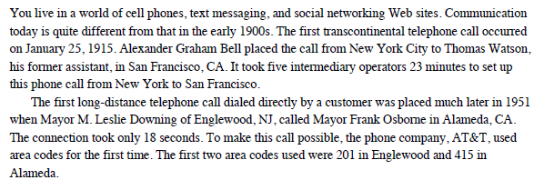

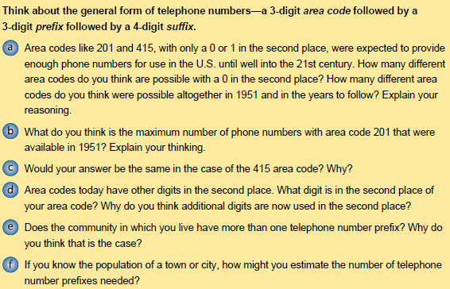

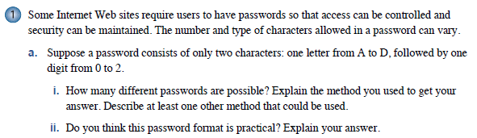

OVER 🡪

Page 2

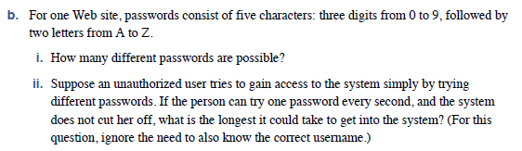

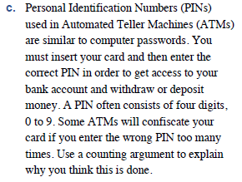

***\*\*\*Just discuss this; you don’t have to write anything.***

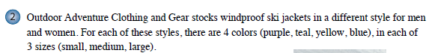

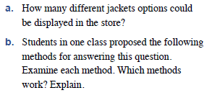

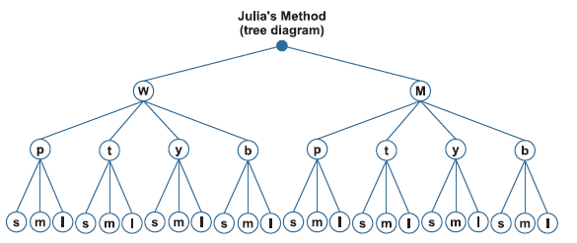

**\*\*\*See next page for 4 more methods.**

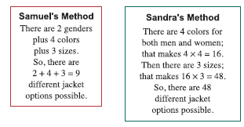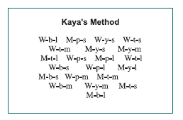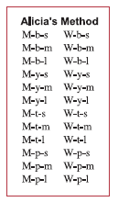  Page 3

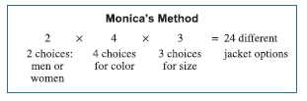

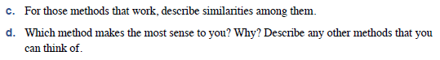

***Just discuss; don’t write anything.***

***Just discuss; then create your own display.***

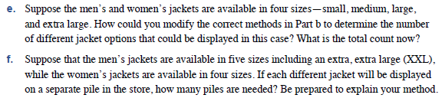

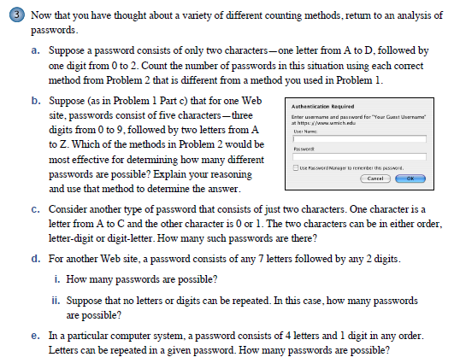

Julia:

Alicia

Monica:

OVER 🡪

 Page 4

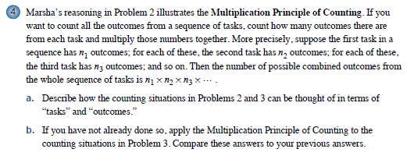

Page 5

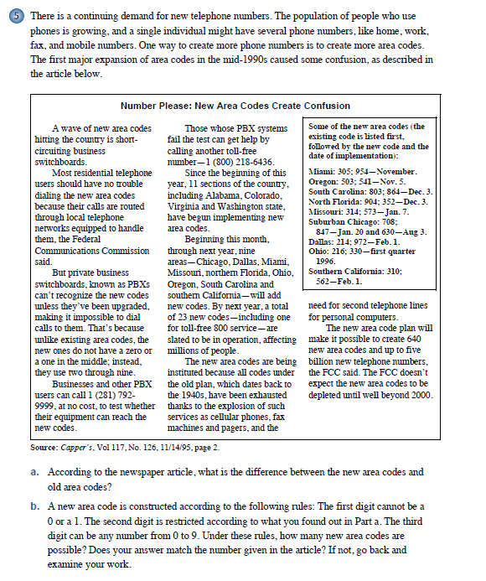

OVER 🡪

Page 6



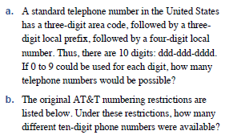 

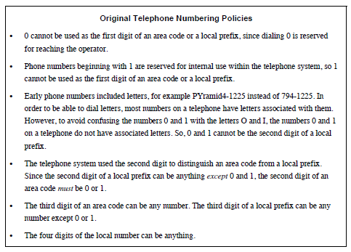

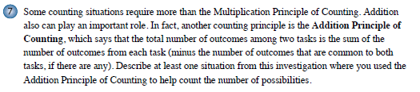

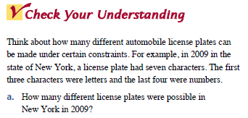

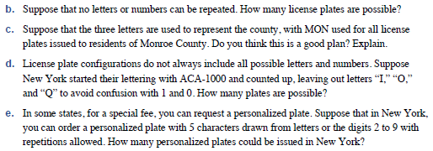

**Lesson 5-1 Homework**

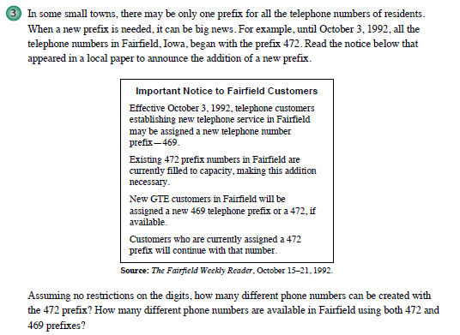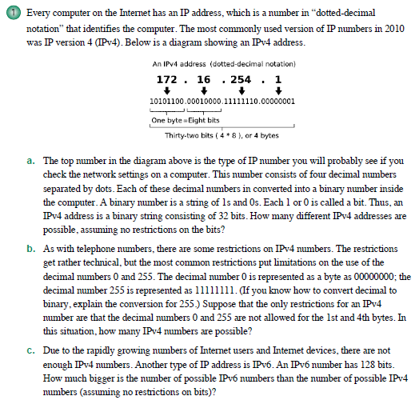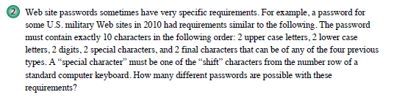





OVER 🡪

